TEST DOCUMENT

**Project:** L*EV3*RON

**Task:** Construct a robot that can play forward or defence in a game of soccer/basketball

**Document Version Number**: 1.13

**Date:** 08-04-17

**Author:** Alexandre Tessier, Tyrone Wong, Andrei Guevorkian

|  |  |  |  |  |
| --- | --- | --- | --- | --- |
| **Version** | **Date** | **Sections Updated** | **Summary** | **Author** |
| 1.0 | 27-02-17 | All (1,3,4) | Preliminary version of the document | Alexandre |
| 1.1 | 28-02-17 | 4.1 | Performed the Ultrasonic Sensor Consistency Test | Tyrone |
| 1.2 | 06-03-17 | 2, 5 | Added section 2 and section 5 and a description of the methodology used for the Color Sensor Accuracy Test | Andrei |
| 1.3 | 07-03-17 | 4.1, 5 | Added the Color Sensor Accuracy Test results | Andrei |
| 1.4 | 13-03-17 | 4.1, 5 | Added Exact Wheel Radius Test and Exact Wheelbase Length Test | Andrei |
| 1.5 | 19-03-17 | 5 | Track value decision | Tyrone |
| 1.6 | 22-03-17 | 4.2, 5 | Added Localization Test | Andrei |
| 1.7 | 27-03-17 | 2.4, 4.2, 5, | Added Ball Launching Consistency Test, Navigation Test, and Varying Ambient Light Test, in addition to section 2.4 | Andrei |
| 1.8 | 30-03-17 | 4.2, 5 | Added results of Varying Ambient Light Test, revision of Localization Test, completion of the Ball Launching Test and updates in section 5 | Andrei |
| 1.9 | 31-03-17 | 4.1, 4.2, 4.3, 5 | Revision and correction of all previous tests completed, and addition of the Navigation and Ongoing Localization Test | Andrei |
| 1.10 | 01-04-17 | 5 | Updates on Navigation | Tyrone |
| 1.11 | 02-04-17 | 4.2, 4.3, 5 | Completion of the Navigation and Ongoing Localization Test and the Obstacle Avoidance Test | Andrei |
| 1.12 | 04-04-17 | 4.3, 5 | Completion of Integration Testing | Andrei |
| 1.13 | 08-04-17 | All | New project name, typos corrected | Alexandre |

# **1. TABLE OF CONTENTS**

**1. TABLE OF CONTENTS** **2**

**2. TESTING PROCESS** **3**

2.1 Phase 1 : Testing of the Hardware Components 3

2.2 Phase 2 : Testing of the Software Features 4

2.3 Phase 3 : Integration Testing 4

2.4 A Note on Updates and Decisions 5

2.5 List of All Tests 5

**3. TEST REPORT TEMPLATE** **6**

**4. TEST REPORTS** **7**

4.1 Phase 1 : Testing of the Hardware Components 7

Ultrasonic Sensor Consistency Test 7

Color Sensor Accuracy Test 9

Exact Wheel Radius Test 14

Exact Wheelbase Length (Track Value) Test 16

4.2 Phase 2 : Testing of the Software Features 18

Localization Test 18

Varying Ambient Light Test 20

Navigation Test 23

Ball Launching Consistency Test 25

4.3 Phase 3: Integration Testing 28

Navigation and Ongoing Localization (X/Y Correction) Test 28

Navigation and Obstacle Avoidance Test 30

Complete System Test 32

**5. UPDATES AND DECISIONS** **33**

# 

# 2. TESTING PROCESS

Testing is a crucial part of the design process. A system consists of numerous subsystems, which all need to be tested both individually and as a whole. A test resembles an experiment in that there are procedures to follow (these procedures can be written by oneself or taken from somewhere else), but the end goal of a test is to identify any weakness of the system in question. The process of testing considerably increases the likelihood that the requirements provided by the clients are continuously followed and met. In other words, testing is used to see if the built system (or the various subsystems) meets all the requirements. In the event that it does not, more testing and experimenting is required in order to design an optimal solution. The testing process was divided in three parts: testing of the hardware components, testing of the software features, and testing of the system.

Also, testing is a long and ongoing process, required to be done by anyone who wants to add something to the software design. This document is by no means a full list of every single test performed throughout this design project. To write and debug code, quick tests are required to see what the outputs are for a given input, as this is not always obvious. This document does however contain all of the formal tests done with concrete measurements and data. Most of them are done to check the finalized version of the code (putting them into more different situations), although some were performed and labelled as “preliminary” to show that they were done at key points in the process where the software team needed concrete data in order to proceed more effectively.

Before proceeding, however, it must be noted that a certain tolerance in error is accepted in all tests, as the clients left room for “inexactitude”. The magnitude of the tolerance were determined for each subsystem and were approximated with respect to the amount of error allowed in the whole system until specifications are no longer met.

## 2.1 Phase 1 : Testing of the Hardware Components

First, the hardware components that were used in the final design were separately tested. This phase uses a looser definition of a “test”, as instead of seeking weaknesses in the components, the goal is to find out which sensors perform the best. After the completion of the sets of tests specific to each component, the most accurate sensor(s) in each category was chosen to be used for the final design. The components referred above are the following: light sensors and ultrasonic sensors. Testing these components of the robot increased our understanding of their workings and helped detect any flaws in the devices.

The final pick of the hardware components to be used in the final product, a crucial factor to the success of our design, can have a definite impact on the final design’s ability to function properly and, most importantly, reliably. Knowing their limitations helped when attempting to diagnose problems in various stages of the design process.

In addition to the sensors, precise values were obtained of both the wheel radius and the wheelbase length. These more precise values were directly used in the code that was used throughout the rest of the phases.

## 2.2 Phase 2 : Testing of the Software Features

In the second testing phase, the software features to be used in the final product were each be tested separately. These features include localization, varying ambient light algorithm, navigation and the ball launching mechanism.

This phase could begin once both the software code and the hardware design were set for at least one of the features to be tested. For example, the actual ball launcher had to be finalized along with its respective code before testing could be done. The main goal here was to try to make the software work with the given hardware design, as it is simpler to adjust a series of values in the code than to completely redesign hardware.

The main goal of this phase is to find any flaw in the software design. This means testing the robot in as many “uncomfortable” situations as possible. For example, although there was a very low chance that, during the actual competition, it would be extremely dark, the case of extreme darkness was still tested in the Varying Ambient Light Test.

## 2.3 Phase 3 : Integration Testing

Once the separate components are combined and the features are all included in the system, the robot can be tested as a whole to see if it is capable of performing the tasks required by the clients. Typically, the design process involves multiple loops of testing around the final prototype. Problems that were undetectable previously in separate tests can now show up, and new tests may have to be conducted to solve the unanticipated problems. The robot might thus have to be modified accordingly, and the same set of tests may need to be repeated until a well-functioning product is made. It must be noted that unexpected problems can arise mostly because the error in the final system is the result of the accumulation of the relatively small errors in each subsystem used (i.e. hardware components and software features).

Just as in Phase 2, the robot was placed in many “uncomfortable” positions, to find out where, exactly, does it breaks down. For example, after conducting basic tests on the robot performing navigation with obstacle avoidance by placing nothing in the robot's path, the next round of tests may include several blocks placed in different ways in front of the robot. Those tests also varied in difficulty, as the width and number of gaps between blocks increases difficulty.

The final week was mainly allocated for this testing phase, in the expectation of settling on a final product on time and on budget.

## 2.4 A Note on Updates and Decisions

A crucial part to the design process is the documentation of the entire process. From conception in the mind, to the writing of a test and to the actual performance of the test, the details of the testing process are kept in section 5 of the document. Note that most of the content in this section was written by the testing team leader (Andrei), with the exception of certains paragraphs followed by the name of the author.

## 2.5 List of All Tests

Phase 1

1. Ultrasonic Sensor Consistency Test
2. Color Sensor Accuracy Test
3. Exact Wheel Radius Test
4. Exact Wheelbase Length Test

Phase 2

1. Localization Test
2. Varying Ambient Light Test
3. Navigation
4. Ball Launching Consistency Test

Phase 3

1. Navigation and Ongoing Localization (X/Y Correction) Test
2. Navigation and Obstacles Avoidance Test
3. Complete System Test

# 3. TEST REPORT TEMPLATE

*Name of the Test*

**Date:** *Day-Month-Year*

**Tester:** *Name of the team member involved in the test*

**Author:** *Name of the team member in charge of writing the test report*

**Hardware Version:** *Hardware version of the robot*

**Software Version:** *Software version of the robot*

**Goal:** *Brief description of the purpose of the test*

**Procedure:** *Detailed description of the steps performed to carry out the test*

**Expected Result:** *Brief explanation of the predicted outcomes, based on current knowledge*

**Test Report:** *Provide the relevant data acquired during the test, along with an analysis of the results. The number of times the test was performed must be included.*

**Conclusion:** *Specify the outcome of the test, if the requirements were met, etc.*

**Action:** *Based on the results, provide a list of what needs to be done. Keep in mind that the Gantt chart might need to be updated.*

**Distribution:** *Indicate which sections of the team need to be made aware of the results of the test in order to, if necessary, make modifications.*

# 4. TEST REPORTS

## 4.1 Phase 1 : Testing of the Hardware Components

### Ultrasonic Sensor Consistency Test

**Date:** 28-02-17

T**ester:** Tyrone Wong, Andrei Guevorkian

**Author:** Tyrone Wong, Andrei Guevorkian

**Hardware Version:** N/A

**Software Version:** N/A

(No hardware and software version due to the use of the built-in sensor testing application located in the tools option in the EV3 selection menu)

**Goal:** Determining the accuracy of the ultrasonic sensors. By testing and seeing which ultrasonic sensor has the least amount of inconsistencies in the distance it measures, we will be able to distinguish which ultrasonic sensor is best suited for accurate object avoidance and initial localization.   
**Procedure:**

1. Turn on the EV3 brick and make sure that it is running at a battery level of over 7.5.
2. Connect the ultrasonic sensor with an appropriate cable into any sensor port located on the EV3 block.
3. Navigate to the tools application on the EV3 and select Tools>Test Sensors>GO>Port 1>EV3 Ultrasonic>Distance. Select the correct port the ultrasonic sensor is attached to (if not Port 1).
4. Record distances from each tile and compare the measured value to the actual value. For example, 1 tile from the wall is 30.48 cm, which is to be compared with the measured value, then 2 tiles is 60.96 cm, which is to be compared with the measured value at that distance, and so on up to a distance of 8 tiles away from the wall. Please refer to the Figure 4.1.1 and 4.1.2 below.
5. Calculate the average error along with their standard deviations and compare all test results of the different sensors.

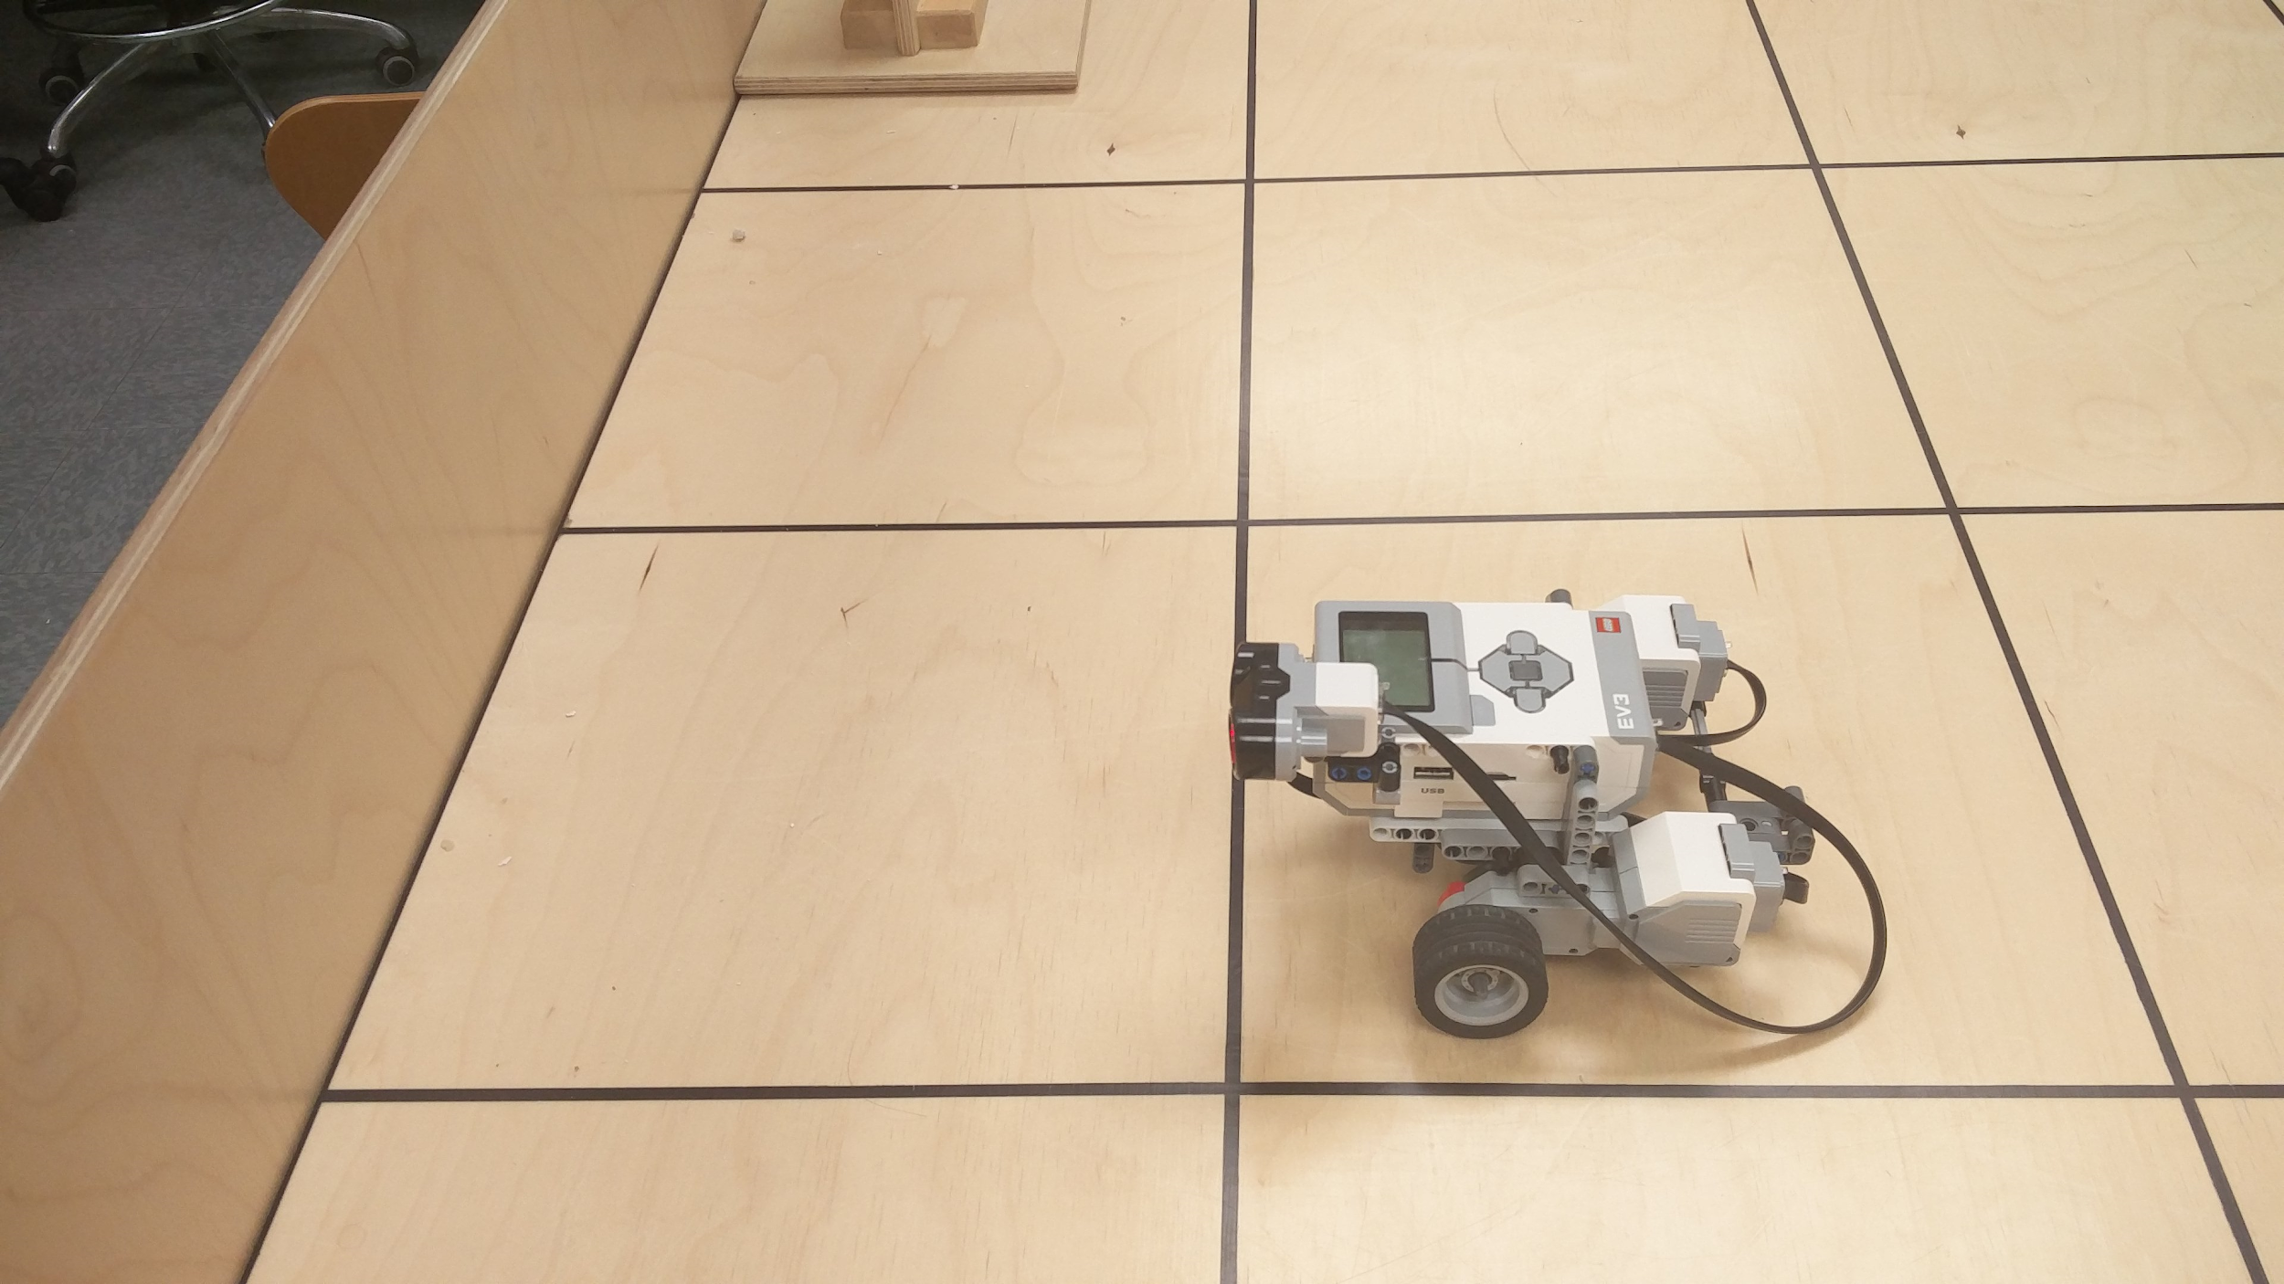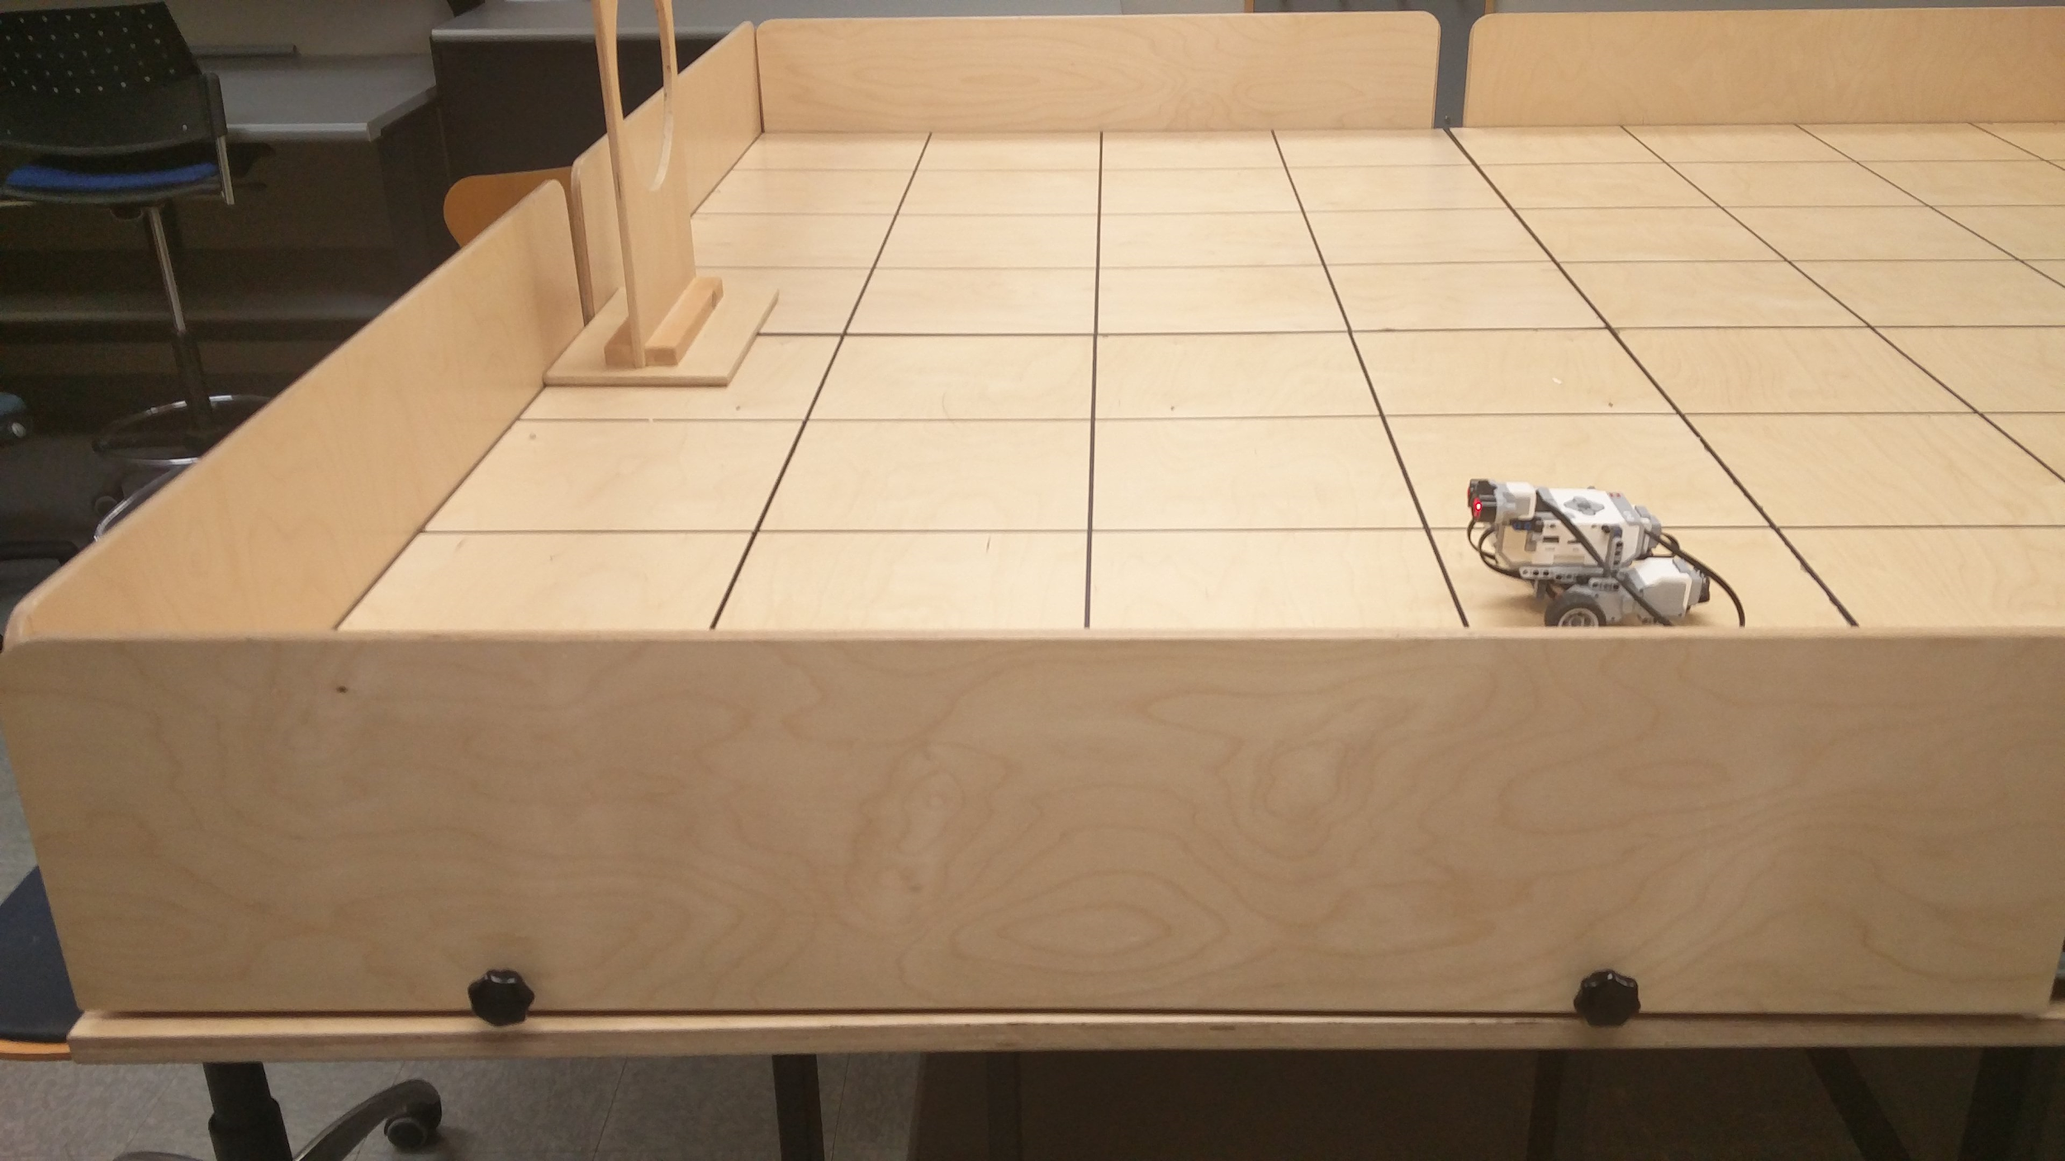

*Figure 4.1.1 and 4.1.2 : Placement of the ultrasonic sensor during the test*

**Expected Results:** Assuming the manufacturing process of the ultrasonic sensor is not 100% consistent for each one produced (and our placement of the ultrasonic sensor is not perfectly perpendicular to the line, nor is it exactly on the center of the line), we expect, under the same conditions, all ultrasonic sensors to display small inconsistencies when measuring distances from some fixed locations. This means that some will perform better than others.

**Test Report:**

|  |  |  |  |  |  |  |
| --- | --- | --- | --- | --- | --- | --- |
|  | **Sensor 1 (Team 34)** | | **Sensor2 (Team 12)** | | **Sensor 3 (Team 4)** | |
| **Real distance (m)** | **Distance measure (m)** | **Error (m)** | **Distance measured (m)** | **Error (m)** | **Distance measured (m)** | **Error (m)** |
| **0.0000** | 0.03 | 0.03 | 0.031 | 0.031 | infinity | infinity |
| **0.3048** | 0.3080 | 0.008 | 0.3200 | 0.0152 | 0.326 | 0.0212 |
| **0.6096** | 0.6160 | 0.0064 | 0.62400 | 0.0144 | 0.618 | 0.0084 |
| **0.9144** | 0.9233 | 0.0089 | 0.9330 | 0.0186 | 0.917 | 0.0026 |
| **1.2192** | 1.2252 | 0.006 | 1.2770 | 0.0578 | 1.219 | 0.0002 |
| **1.5240** | 1.5271 | 0.0031 | 1.5340 | 0.01 | 1.527 | 0.003 |
| **1.8288** | 1.8396 | 0.0108 | 1.8490 | 0.0202 | 1.829 | 0.0004 |
| **2.1336** | 2.1718 | 0.0382 | 2.1630 | 0.0294 | 2.136 | 0.0024 |
| **2.4384** | 2.4630 | 0.0246 | 2.4650 | 0.07884 | 2.441 | 0.0026 |

|  |  |  |  |
| --- | --- | --- | --- |
|  | **Sensor 1** | **Sensor 2** | **Sensor 3** |
| **Average Error (m)** | 0.015111111 | 0.030604444 | 0.0051 |
| **Standard Deviation** | 0.008953185 | 0.023034369 | 0.006973419 |

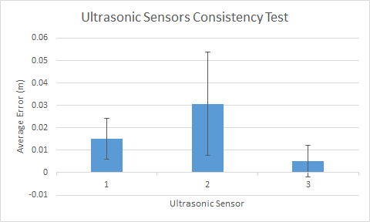

**Conclusion:** The average error of Sensor 3 is relatively low compared to the other two sensors, and it has the lowest standard deviation in the group. This means that it is relatively more accurate and consistent with its measurements.

**Action:** Use Sensor 3 (which belonged to Team 4) for the remainder of the design project. However, if we decide to change the hardware design and use more than one ultrasonic sensor, Sensor 1 should be prioritized.

**Distribution:** Hardware team

### Color Sensor Accuracy Test

**Date:** 06-03-17

T**ester:** Andrei Guevorkian

**Author:** Andrei Guevorkian

**Hardware Version:** N/A

**Software Version:** N/A (code adapted from the SSH tutorial)

**Goal:** Determine which of the three color sensors performs best by testing to see which one has the clearest (or “sharpest”) detection of black lines from different heights.  
**Procedure:**

1. Turn on the EV3 brick and make sure that the battery level is over 7.5.
2. Start by attaching the color sensor onto the robot in such a way that it points perpendicularly towards the platform from a height of approximately 1.5 cm. Refer to Figure 4.1.3 and 4.1.4 below.
3. Place the robot in such a way that it will read each black line perpendicularly as it moves on the field. Run the program.
4. With the data collected by the color sensor, connect the EV3 Brick to a computer, where the “Starts the EV3Control GUI tool” button is found on Eclipse.
5. Click on that button, and then click on “Search” in the EV3 Control Center window. In there can be found the data collected, which can be opened in Excel.
6. Repeat the previous steps a second time (denoting it as trial 2) for the same conditions (same height and same sensor).
7. Repeat the previous steps with the other two sensors, keeping the same height.
8. Decrease the height from the sensor to the platform (from 1.5 cm to 1.3 cm to 0.7 cm) by slightly modifying the hardware design which holds the sensor, and repeat the previous steps for all 3 color sensors.
9. Create a scatter chart for each data set collected, and calculate the approximate average difference value (this is the difference between the average of the extreme points and the approximate average of the sample) for each trial, sensor and height. Note that when looking for the “approximate average of the sample”, the values creating a peak can be ignored completely. For example, if separate peak points have values of 1, 1.2 and 1.3, then you would take the average of those, which is (1+1.2+1.3)/3 = 1.167.

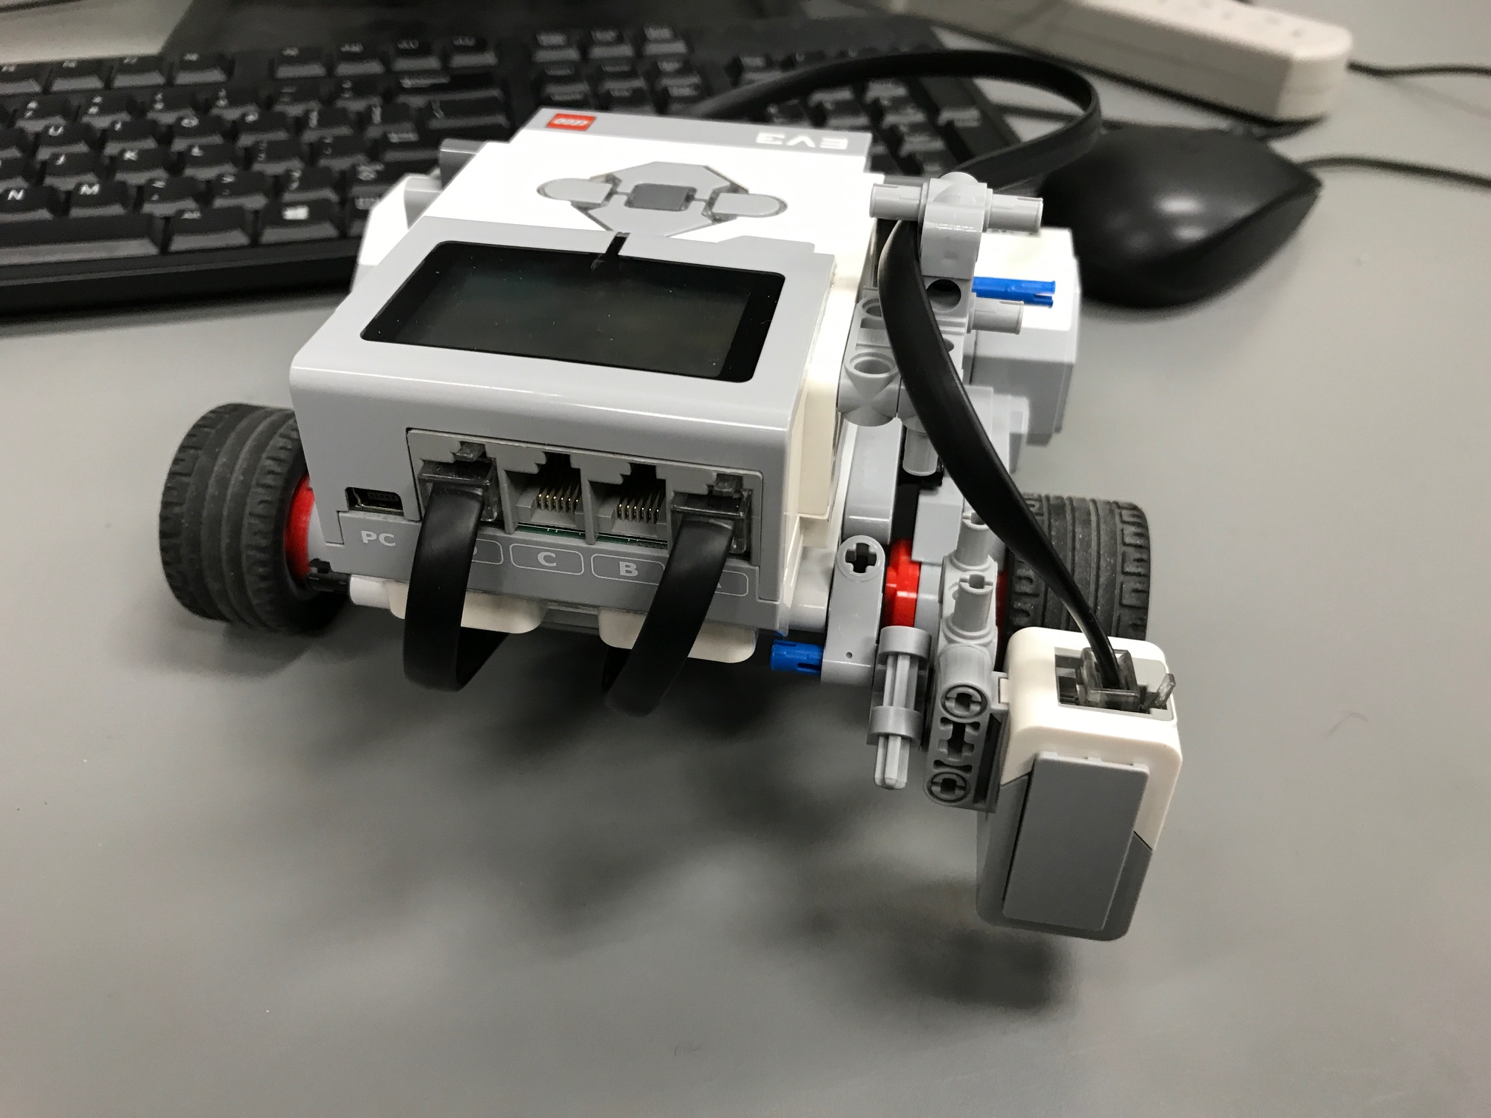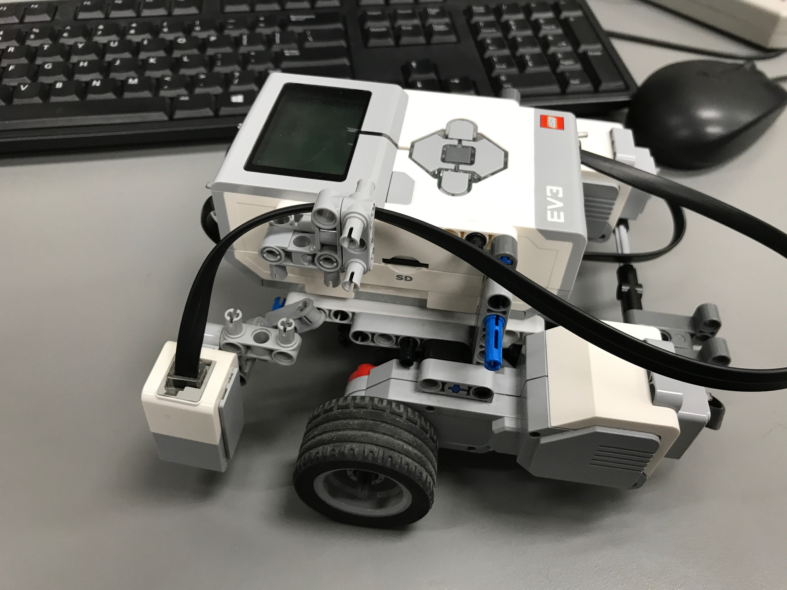

*Figure 4.1.3 and 4.1.4 : Perpendicular placement of the color sensor on the EV3 brick*

**Expected Results:**

Assuming the manufacturing process of the color sensor is not 100% consistent for each one produced, we expect, under seemingly similar conditions (some dust particles may land on the field at some point throughout the test, for example), all color sensors to display small inconsistencies when measuring light intensity. This means that some will perform better than others. More precisely, the one that will have points that separate themselves more clearly than others (these are the values measured near the center of the black lines) will be selected as this property increases chances of detection of grid lines.

**Test Report:**

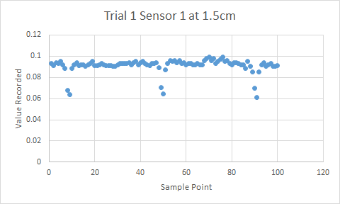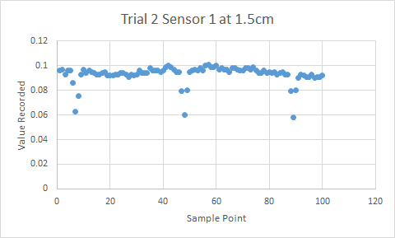

For sensor 1, trial 1 at 1.5 cm of height, two points per passing of a black line gave values that clearly stood out with value differences of about 0.03. For trial 2 at the same height, one point per passing of a black line clearly stood out, yielding value differences of about 0.038.

The average value difference is 0.034.

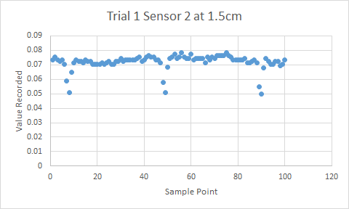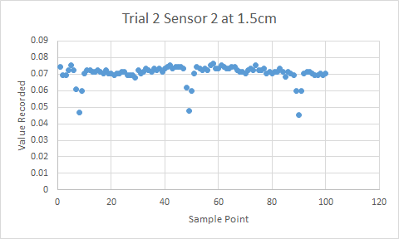

For sensor 2, trial 1 at 1.5 cm, two points per passing clearly stood out (difference value of about 0.025). Trial 2 gave a difference value of about 0.025 with one clear point per passing.

The average value difference is 0.025.

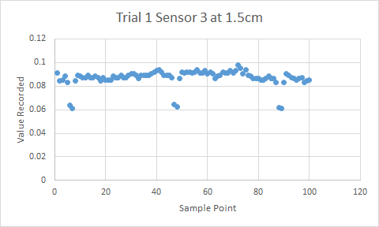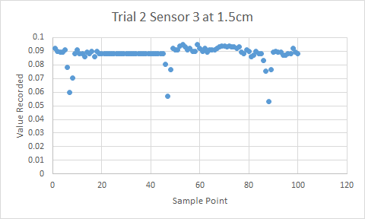

For sensor 3, trial 1 at 1.5 cm, two points per passing stood out, yielding a difference value of 0.029. At trial two, the difference value was about 0.03.

The average value difference is of 0.0295.

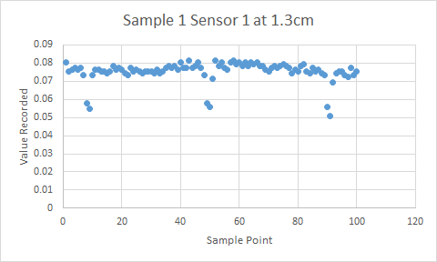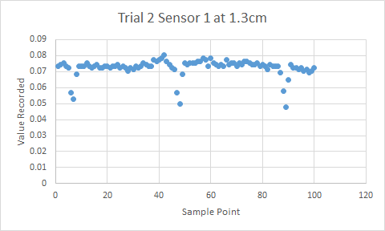

Trial 1 yields a difference value of 0.021, while trial 2 gives 0.025.

The average value difference difference is 0.023.

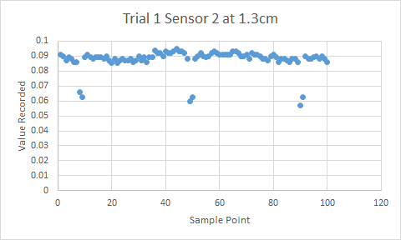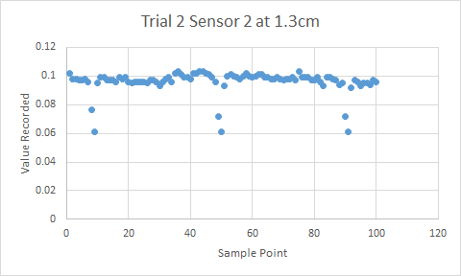

Trial 1 yields a difference value of 0.028, and trial 2 gives 0.035.

The average value difference is 0.0315.

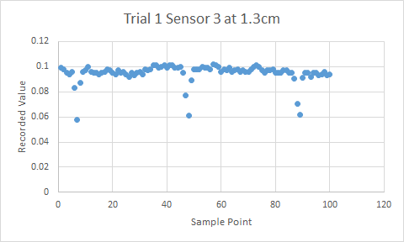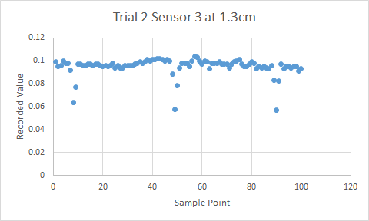

Trial 1 yields a difference value of 0.033, and trial 2 gives 0.038.

The average value difference is 0.0355.

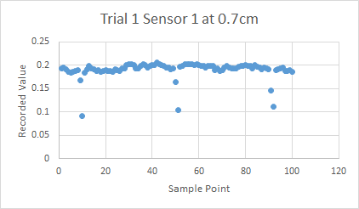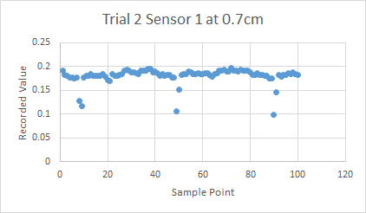

Trial 1 yields a difference value of 0.085, and trial 2 gives 0.065.

The average value difference is 0.075.

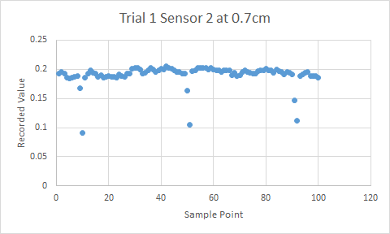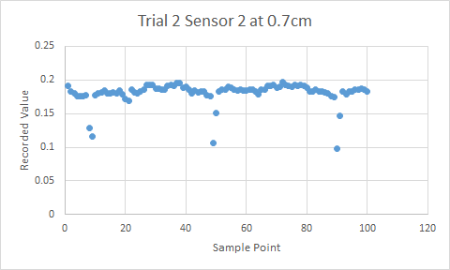

Trial 1 yields a difference value of 0.09, and trial 2 gives 0.07.

The average value difference is 0.08.

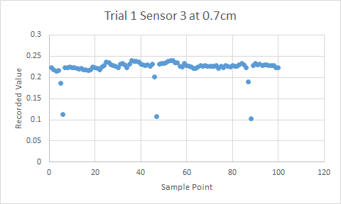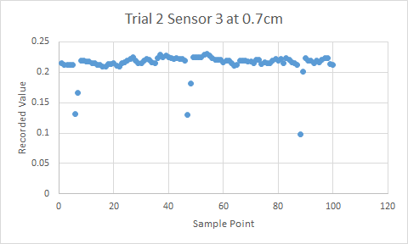

Trial 1 yields a difference value of 0.11, and trial 2 gives 0.09.

The average value difference is 0.1.

**Conclusion:** Comparing the average value differences of all 3 sensors for any given height, it can easily be seen that the differences between the sensors are minimal and cannot be detected with tests of this quality. However, there is no need for more more precise testing, as this test shows that all 3 color sensors would get the job done equally well as they can each detect the black lines with at least one data point for each black line (which is all we need).

**Action:** No action to be taken. No further tests are required to determine which one of the three color sensors is the better one. There is also no need to test the color sensors capabilities when the robot is moving diagonally with respect to the grid lines, because detecting the black lines perpendicularly (approximately) ensures that the thickness is minimal (which is the worst case scenario). Therefore, if the sensor detects a black line when moving perpendicularly, it will certainly detect it when moving diagonally, and all three color sensors got the job done. However, one final test on the color sensor will still have to be done at different ambient light levels.

**Distribution:** Hardware team

## 

### Exact Wheel Radius Test

**Date:** 13-03-17

T**ester:** Andrei Guevorkian

**Author:** Andrei Guevorkian

**Hardware Version:** 1.0 (see section 10.1 in the Hardware Design document)

**Software Version:** N/A

**Goal:** Determine to a higher degree of precision the wheel radius’ value that will be used by both the prototype version (for the software tests) and the final product (since wheels are identical).

**Procedure:**

1. Measure the wheel radius with a ruler.
2. Write a program to make the robot travel 91.44 cm in a straight line (this is exactly the length of 3 tiles) at a speed of 50 and have it accelerate and decelerate very slowly. Use the value measured in step 1 in the code.
3. Run the program and measure (with a ruler) the error of the final position of the robot.
4. Repeat steps 2 and 3 seven more times.
5. Find the average of the errors and add that value to the distance traveled (91.44 cm in this case) in the following formula to find the exact wheel radius:

$Radius=distance traveled/2π*number of rotation$, where number of rotations is 6.93 (as calculated below).

**Expected Results:** There should be a constant distance error from run to run since the distance traveled is influenced by the wheel radius. However it will not always be the same because of the error in manual measurements (done with a ruler).

**Test Report:**

|  |  |
| --- | --- |
| **Run #** | **Distance error (cm) +/- 0.2 cm**  **Using wheel constant of 2.1 cm** |
| **1** | **-0.8** |
| **2** | **-0.7** |
| **3** | **-0.9** |
| **4** | **-0.8** |
| **5** | **-1.2** |
| **6** | **-1.8** |
| **7** | **-0.9** |
| **Average =** | **-1.01** |

**Number of rotation done by the motor to travel 91.44 cm as stated by the program:**

$number of rotation=distance traveled$**/($2π*ideal radius$)**

$number of rotation=91.44/(2π*2.1)$

$number of rotation=6.93$

$Radius=distance traveled/2π*number of rotation$

$Radius=(91.44-1.01)/2π*6.93$

$Radius=2.0768 cm$

|  |  |
| --- | --- |
| **Run #** | **Distance error (cm ) +/- 0.2 cm**  **Using wheel constant of 2.0768 cm** |
| **1** | **0** |
| **2** | **-0.1** |
| **3** | **-0.1** |
| **4** | **-0.2** |
| **5** | **-0.2** |
| **6** | **-0.3** |
| **7** | **0** |
| **Average =** | **-0.13** |

**Conclusion:**The test is a success, as the formula worked quite well (decreasing the average error by almost 1 cm). The average is not 0, but considering the uncertainty in measurements (e.g placing the robot perpendicularly to the black lines, measuring starting and ending distances with a ruler), it could be considered acceptable by some. However, it can be seen that the robot came short almost every time, instead of varying around the 0 point. For that reason, minor tweaks in the value will be done.

When the radius was set to 2.1 cm, it fell short even more (-1.01 compared to -0.13). By decreasing its value therefore, we will approach the 0 error point. Thus, starting from 2.0768 cm, a minor test will be conducted to get even closer to the aimed line by decreasing the value until no error in distance is visible (no additional test report will be written).

**Action:** First, run a few tests to find a slightly lower value for the wheel radius that allows to approach the destination even more. After that’s done, change the value of the wheel radius in all software programs from 2.1 cm to whatever is found in the previous step (it turns out to be 2.06 cm). 2.06 cm is what was found in the “post-testing” session described above, and use this value for the remainder of the design process.

**Distribution:** Software team

### Exact Wheelbase Length (Track Value) Test

**Date:** 13-03-2017

T**ester:** Andrei Guevorkian

**Author:** Andrei Guevorkian

**Hardware Version:** 1.0 (see section 10.1 in the Hardware Design document)

**Software Version:** N/A

**Goal:** Determine to a higher degree of precision the track value that will be used by both the prototype version (for the software tests) and most probably the final product (there are no plans to modify the chassis).

**Procedure:**

1. Using the turnto() method, have the robot do two complete turns (at some track value) at a relatively low speed (we used an acceleration of 100 and rotation speed of 130) to minimize slip.
2. Measure the error in angle using a protractor.
3. If the robot did more than exactly two turns around itself, then lower the track value in the code (and vice-versa if it rotated too little), and repeat step 2.
4. Continue this process until a minimal error in angle is reached.
5. Once the exact value is thought to be found, test that value 5 more times to make sure.
6. If the value seems to work, test it again at a later times to ensure its consistency.

**Expected result:** Having first worked with the track value in the R&D phase, it is well known to be off of its actual value. In my personal experience, we would have to sometimes modify it even if the actual hardware designed was not changed. It will be of no surprise if different results occur at different times (e.g. due to battery charge level). After following the procedure explained above, the angle error of the track value to be found should be 0° ± 3°. This error is primarily due to human error and the inexactitude of measurements.

**Test report:** With the starting value of 13.55 cm that I already had in my code (this is an arbitrary value, as it was used for a completely different robot design), the robot overshoots by around 40°. Therefore, the value will be decreased to 10 cm. It must also be noted that the battery level is at 7.7, and that all angles below the value of 5° have an uncertainty of +/-2° (and those above that are rough estimates).

1. Using 10 cm, it fell slightly short (by about 10°).
2. At 10.4 cm, it overshoots by about 30°.
3. At 10.1 cm, it came short by about 3°.
4. At 10.15 cm, it overshoots by 10° (tested twice in a row).
5. At 10.11 cm, it overshoot by about 6°. (Battery level at 7.4 at this point)
6. At 10.1 cm, it overshoots by about 5° (tested 5 times in a row).
7. Recharge to 7.7 battery level.
8. At 10.1 cm again, it overshoots by around 5°
9. At 10 cm, it fell short by about 3° (tested twice).
10. At 10.05 cm, it overshoots by about 3°.
11. At 10.03 cm, it also overshoots by about 3° (tested three times).
12. At 10.02 cm, it came short by about 2° (tested 5 times).
13. 30 minutes have passed.
14. At 10.02 cm, the robot rotates at -5°,0°, 0°, 0°, +1°, 0°.
15. Retesting of the value found yesterday (see Section 5, Sunday, March 19) of 10.08 cm: +5°, +3°, +3°.
16. 12 hours have passed. (battery now at 7.6)
17. At 10.08 cm, the robot rotates -20°.
18. At 10.02 cm, -20° (twice).

*Figure 4.1.5: The longer pieces added on both side of the wheels were used to help calculate the angles.*

**Conclusion:** It can be seen how at 3), with a value of 10.1 cm, the robot came short by 3°, while at 8), with the same track value of 10.1 cm, the robot passed the destination by 5°. This demonstrates the “volatility” of the track value when running at different times. Furthermore, re-testing for the same track value 12 hours later (16)) yielded a completely different result (compared to 14)). Although the robot will be turning more than twice around itself throughout the competition (thus previously undetectable errors will now surface), the continuous use of light localization should take care of any small problem, resetting the orientation of the robot based on the detection of grid lines.

**Action:** Keep the value at 10.08 cm as it was before, as this was the value used during the testing navigation (as discussed in Section 5, *Sunday, March 19*).

**Distribution:** Software team

## 4.2 Phase 2 : Testing of the Software Features

### Localization Test

**Date:** 22-03-17

T**ester:** Andrei Guevorkian

**Author:** Andrei Guevorkian

**Hardware Version:** 1.1 (see section 10.2 in Hardware document)

**Software Version:** 1.3 (see Software document for details)

**Goal:** See if the robot can successfully, and reliably, localize (using both ultrasonic and light localization techniques) and do it within, ideally, 25 seconds to allow for a certain margin of error.

**Procedure:**

1. Place the robot within the boundaries of a corner tile (surrounded by two walls) in such a way that it can freely rotate without hitting a wall.
2. Run a localization program on the EV3 Brick (this includes ultrasonic localization followed by light localization).
3. Repeat the previous steps with different initial orientations (while keeping the center of the robot on the imaginary diagonal of the square), making sure to test it in as many different positions as possible (20° difference between each run).
4. These steps may be repeated several times, testing different localization code. If done so, each different version of localization tested should be considered as separate tests (but all included in one test report).

**Expected Results:** It is expected that the robot does not first succeed under all circumstances. It is anticipated that it fails when initially facing the walls. This will be done as a preliminary test, to then fix the problems observed. Then, after fixes to the code, we expect the robot to succeed under all circumstances (any initial position and orientation). Its operating procedure should be as follows: it will rotate a couple of times on both sides, get needed angles (using the ultrasonic sensor and the surrounding walls) and position itself facing approximately towards the nearest cross section of the gridlines. Then the robot will move forward until all 4 intersecting lines are within the reach of the light sensors. It should then rotate on the spot (starting from the detection of the +x grid line) until it detects all four lines. Then, it should move towards the center of the grid intersection (with the point between its wheels at the cross-section), and rotate to face the +y-axis.

**Test Report:**

A preliminary test was performed with the initial Localization code. The data can be accessed in the Localization Test 1 document. Note that, for this test, the reason for failure of each run is in bold.

A second test was performed with the updated version of the Localization code (with changes made according to the preliminary test). The data of the second test can be accessed in the Localization Test 2 document.

It must also be noted that the tests where the center of the robot’s wheelbase was not placed on the diagonal (or very near it) resulted in failures, and these tests were not included in the documents mentioned above.

**Conclusion:** The preliminary test showed the weak spots of the localization code, i.e. when the robot faces some parts of the walls (as seen in runs 12 to 18). Other reasons for failures include the errors in angle of over 4° (runs 2 to 4), the time elapsed of 25 seconds or more (runs 8 and 16), and the initial detection of the +y grid line (runs 8, 16 and 18). All of this was taken into account by the software team and the errors were corrected, allowing for another localization test to be conducted.

In the second test, it can be seen that the errors found in the preliminary test were fixed, and localization works at any initial angle. However, a new consistent error has appeared throughout all runs: there is an overall error in position of around 0.5 cm and a minor fluctuating error in the final angle. These values are now acceptable because, first of all, the track value is volatile (as seen in the Exact Wheelbase Length Test) and trying to perfect localization may be an impossible task due to this. Second, a correcting system will be implemented that will correct any inconsistencies due to navigation and localization. For this reason, all the runs were labeled as “success”.

During the competition, it is assumed that the TAs will do a good job of placing the robots on the diagonal (as they should). If this initial step is not done properly, then localization will not work properly.

**Action:** No further explicit testing of localization is needed.

**Distribution:** Software team

### Varying Ambient Light Test

**Date:** 27-03-17

T**ester:** Andrei Guevorkian

**Author:** Andrei Guevorkian

**Hardware Version:** 1.2 (see section 10.3 in Hardware document)

**Software Version:** N/A

**Goal:** Test the quality of the code that deals with the change in ambient light levels.

**Procedure:**

1. Install the Flashlight Galaxy app on your phone (or any other app with similar features) to use the camera LED light as a flashlight, and the screen light for other colors (only yellow and red will be used for this test).
2. Run a program (without any correcting algorithm for different ambient light levels) that will have the robot drive in a straight line, spanning 6 gridlines. Also, have it beep every time it detects a grid line.
3. Start by keeping the lights of the room on, and count the number of beeps (for a maximum of 6). Repeat once.
4. Keep the lights of the room on, and follow the robot with the flashlight (keep it 10 cm away), pointing downwards at the field, ensuring that the light sensor detects it. Repeat once.
5. Repeat step 3, but holding the flashlight 3 cm away from the sensor.
6. Turn off the lights in the room, keeping only the light coming from outside of the room through the window to illuminate the robot’s path. Repeat once.
7. Keeping the room lights still off, block some light coming from outside sources (from the window) with a big object, leaving a very small amount of light come through. Repeat once.
8. Turn on the app and use a yellow light source to illuminate the path. Hold the phone as close as possible to the sensor to ensure that the light is detected. Repeat once.
9. Repeat the previous step, but with the color red.
10. Repeat all previous steps, but having the light sensor point 10 degrees from the normal (if possible). If your robot’s design does not allow for this, then skip this step. Perform this set of tests only once for each case.
11. If, using the normal program (without any correcting algorithm for different ambient light levels), the sensor is not able to detect all gridlines in any case, create a correcting algorithm to take into account the different ambient light levels, and repeat this test using that program to then compare the results.

**Expected Results:** The robot is expected to work without any correcting algorithm taking into account different ambient light levels. This is because it has already been quickly tested already in a brighter setting, and the robot worked normally.

**Test Report:**

Sensor facing perpendicular to the platform (tested twice):

* With all lights on inside: all 6 lines detected
* With all lights on + flashlight at 10 cm away: all 6 lines detected
* With all lights on + flashlight at 3 cm away: all 6 lines detected
* With all inside lights off (just outside light source): all 6 lines detected
* Blocking outside source: all 6 lines detected
* Only red light: all 6 lines detected
* Only yellow light: all 6 lines detected

Repeating all conditions with the sensor at approximately 10° from the normal of the platform yields the same results, as the robot detected all 6 grid lines in each condition.

*Figure 4.1.6: Condition with only outside light source.*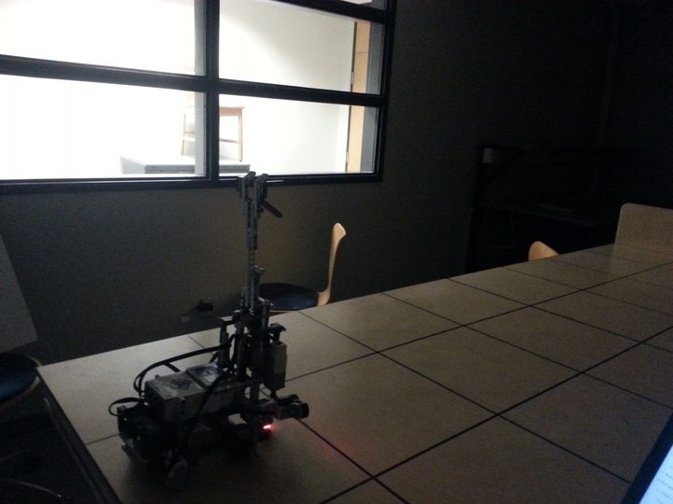

*Figure 4.1.7: Condition with blocking of outside source (minimal* 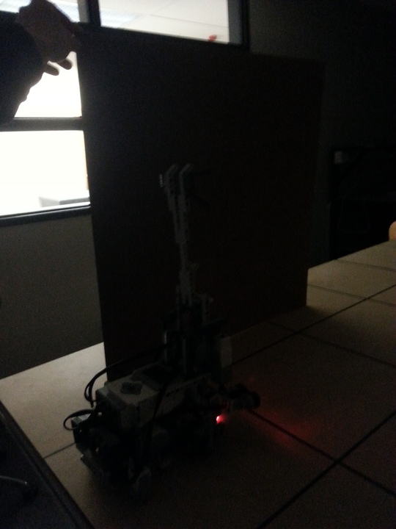

*ambient light condition).*

*Figure 4.1.8: A 10*° *offset of the light sensor w.r.t* 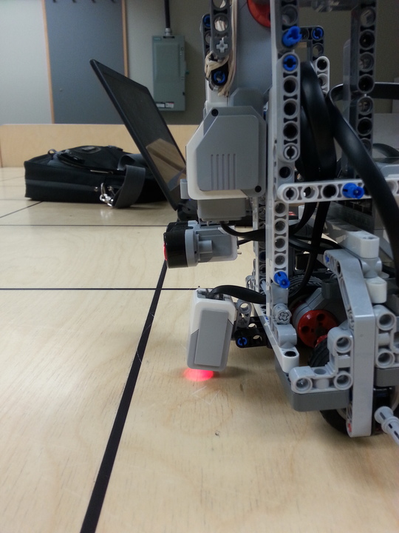

*the normal of the platform.*

## 

**Conclusion:** The color sensor works well in extreme conditions (from very dark to very bright), so there should not be any problem during the competition, no matter the time of the day. Even if (for any reason), the sensor is slightly tilted, it will still detect the lines.

**Action:** Keep the code as it is, without the implementation of the slope based algorithm that was already partially developed. No further action needs to be taken.

**Distribution:** Software team

### Navigation Test

**Date:** 27-03-17

T**ester:** Andrei Guevorkian

**Author:** Andrei Guevorkian

**Hardware Version:** 1.2 (see section 10.3 in Hardware document)

**Software Version:** 3.1 (see Software document for details)

**Goal:** Test the accuracy of the navigation code (along with correction) and determine the maximum distance that the robot is able to travel before re-performing localization (also called X/Y Correction).

**Procedure:**

1. Realize that branching off from the following steps when needed is permitted and even encouraged.
2. Place the robot at (0,0), facing the +y axis as if it were to have already completed the initial localization.
3. Run navigation from the initial position and have the robot travel along the +x axis. Starting with (1,0), then (2,0), then (3,0) and so on. Note that these coordinates are dependant on the dimensions of the field that you have in your possession for testing. In our case, we have a platform of 12x4).
4. Measure the absolute error in the final position and in the final angle (w.r.t. +x axis) for each run.
5. Notice at which coordinate destination, the robot starts to miss its target. Call this coordinate point (X+1,0). This means that when the destination is (X,0), the robot is still navigating fine. Note that the robot is considered to miss its target when there’s an absolute error of over 1 cm in position or over 5° in angle.
6. Have the robot go to (X-1,1) and then re-run it to (X-2,2). Notice if the robot is less precise when rotation is involved (although the overall distance does not change). If the robot does not navigate well enough in these cases, then reconsider the distance where imprecision occurs (a distance of X+1 tiles) and decrease it by 1 or 2, depending on how bad navigation works with rotation.
7. Do more runs using the new total distance (if changed at all), making sure to consider numerous different coordinates.
8. Compare the errors and determine (through your own deductive reasoning) how many tiles away the robot can travel before errors are too great to later be fixed using localization.

**Expected Results:** It is expected that when going straight, the robot can go very far without needing to localize (due to the implementation of the continuous correction by the two light sensors placed in the back to correct the robot’s heading). When there are turns however, the unpredictable nature of the track value should greatly influence how often we do the X/Y correction technique.

**Test Report:**

|  |  |  |  |  |  |  |  |  |  |  |
| --- | --- | --- | --- | --- | --- | --- | --- | --- | --- | --- |
| **Destination** | **(1,0)** | **(2,0)** | **(3,0)** | **(4,0)** | **(5,0)** | **(6,0)** | **(7,0)** | **(8,0)** | **(9,0)** | **(10,0)** |
| **Abs. Error in position (cm)** | 0 | 0 | 0.1 | 0.1 | 0.2 | 0.2 | 0.2 | 0.4 | 0.3 | 0.3 |
| **Angle (°)** | 1 | 1 | 0 | 2 | 1 | 2 | 3 | 2 | 1 | 1 |

Since we do not miss the target when driving only straight, the procedure will not be followed exactly, but a more “empirical approach” will be taken from now on.

|  |  |  |  |  |  |  |  |  |  |  |
| --- | --- | --- | --- | --- | --- | --- | --- | --- | --- | --- |
| **Destination** | **(1,2)** | **(2,2)** | **(3,2)** | **(4,2)** | **(5,2)** | **(6,2)** | **(7,2)** | **(8,2)** | **(9,2)** | **(10,2)** |
| **Abs. Error in position (cm)** | 0.5 | 0.6 | 0.5 | 0.7 | 0.6 | 0.9 | 0.7 | 0.7 | 0.8 | 1 |
| **Angle (°)** | 1 | 1 | 2 | 3 | 0 | 2 | 4 | 1 | 1 | 0 |

**Conclusion:**

The destination on this field are limited to the size of the platform itself, but the data collected is enough to make a conclusion. As we can see from the first part, going in a straight line will keep error in position at minimal. The angle is always corrected when passing a grid line, so the error in angle does not very with distance traveled.

When rotation is involved to get somewhere, the error in position is due to the fact that the robot has to travel at an angle before it is corrected with the light sensors at the back. What happens is that if it rotates to a wrong position (because of the variation in the track value found in the Exact Wheelbase Length Test), it first travels at that wrong position, until a color sensor from the back reaches the grid line, from where a correction occurs and the robot is set back to the correct orientation (hence why the final angle is always good). All that time spent travelling in the the wrong direction is what causes the small error in position.

It was also seen that the robot always deviates slightly when it moves straight. Although small, this is what cause the final angle to be a bit off (although negligible). To stay on the safe side (also taking into account the time limit), it is decided that after every 5 tiles, the robot should re-localize itself and perform the X/Y correction routine. However, this test also assumes that obstacle avoidance is perfect, so changes to this value may be necessary in the future.

**Action:** Add into the code to have X/Y correction occur after every 5 tiles.

**Distribution:** Software team

### Ball Launching Consistency Test

**Date:** 27-03-17

T**ester:** Andrei Guevorkian

**Author:** Andrei Guevorkian

**Hardware Version:** 1.2 (see section 10.3 in Hardware document)

**Software Version:** 3.1 (see Software document for details)

**Goal:** Test the quality of the code that deals with the firing mechanism of the robot.

**Procedure:**

1. Ensure that battery levels are at 8 to begin with.
2. Place the robot facing the hoop from 4 tiles away (perpendicularly).
3. Run a program that will have the robot launch a ball, specifying that the distance is 4 tiles, also measuring and recording the needed data (namely if the ball bounces within the 2x2 area in front of the hoop, and whether or not the ball goes through the hoop).
4. Repeat the previous steps at a distance of 5 tiles, 6 ,7 and then 8, each with its corresponding code (specifying the distance).
5. Repeat the previous steps, but decreasing the battery levels by 0.2, all the way until the launcher fails to hit the target. These battery levels are guidelines to try and figure out at what point does the launcher weaken to the point that it does not satisfy the client’s requirements.

**Expected Results:** Quick tests were performed by the Hardware team leader when writing the program for the launching mechanism, and so it is expected to be consistent and score on all shots. However, it is expected that at different battery levels, we get different results (the lower the battery level, the weaker the launch).

**Test Report:**

Note: In the tables, a Boolean value of 1 indicate a success, as opposed to a 0 which indicates a failure.

*Battery level at 8.*

|  |  |  |
| --- | --- | --- |
| **Distance from target**  **(in # of tiles)** | **Proper bouncing area of 2x2 (Boolean)** | **Goal (Boolean)** |
| **4** | 1 | 1 |
| **5** | 1 | 1 |
| **6** | 1 | 1 |
| **7** | 1 | 1 |
| **8** | 1 | 1 |

*Battery level at 7.8*

|  |  |  |
| --- | --- | --- |
| **Distance from target**  **(in # of tiles)** | **Proper bouncing area of 2x2 (Boolean)** | **Goal (Boolean)** |
| **4** | 1 | 1 |
| **5** | 1 | 1 |
| **6** | 1 | 1 |
| **7** | 1 | 1 |
| **8** | 1 | 1 |

*Battery levels at 7.6*

|  |  |  |
| --- | --- | --- |
| **Distance from target**  **(in # of tiles)** | **Proper bouncing area of 2x2 (Boolean)** | **Goal (Boolean)** |
| **4** | 1 | 1 |
| **5** | 1 | 1 |
| **6** | 1 | 1 |
| **7** | 1 | 1 |
| **8** | 1 | 1 |

***Battery levels at 7.4***

|  |  |  |
| --- | --- | --- |
| **Distance from target**  **(in # of tiles)** | **Proper bouncing area of 2x2 (Boolean)** | **Goal (Boolean)** |
| **4** | 1 | 1 |
| **5** | 1 | 1 |
| **6** | 1 | 1 |
| **7** | 1 | 1 |
| **8** | 1 | 1 |

*Battery levels at 7.2*

|  |  |  |
| --- | --- | --- |
| **Distance from target**  **(in # of tiles)** | **Proper bouncing area of 2x2 (Boolean)** | **Goal (Boolean)** |
| **4** | 1 | 0 |
| **5** | 1 | 0 |
| **6** | 0 | 0 |
| **7** | 0 | 0 |
| **8** | 0 | 0 |

*Battery levels at 7.0*

|  |  |  |
| --- | --- | --- |
| **Distance from target**  **(in # of tiles)** | **Proper bouncing area of 2x2 (Boolean)** | **Goal (Boolean)** |
| **4** | 0 | 0 |
| **5** | 0 | 0 |
| **6** | 0 | 0 |
| **7** | 0 | 0 |
| **8** | 0 | 0 |

**Conclusion:**

The results show that with battery levels at 7.2, the launching mechanism in place starts to break down. The hypothesis is shown to be correct; a decrease in the power provided to the launcher causes the latter to not launch the ball properly anymore. On the other hand, one can make the launcher work with battery levels at 7.0 by simply adjusting the speed of the launcher (this was quickly done and confirmed). However, it would be unnecessary to have the speed of the launcher vary with the battery level, as we expect to run at maximum battery levels throughout a single round in the competition (also quickly tested), give that we start with a fully charged battery.

**Action:** No actions need to be taken.

**Distribution:** Software team, Hardware team

## 

## 

## 4.3 Phase 3: Integration Testing

### Navigation and Ongoing Localization (X/Y Correction) Test

**Date:** 31-03-17

T**ester:** Andrei Guevorkian, Tyrone Wong, Alexandre Tessier

**Author:** Andrei Guevorkian

**Hardware Version:** 1.2 (see section 10.3 in Hardware document)

**Software Version:** 3.2 (see Software document for details)

**Goal:** Test the quality of the code that deals with the correction of the displacement of the position of the robot.

**Procedure:**

1. Have the robot travel in a rectangle with corners (0,0), (0,2), (6,2) and (6,0), starting from the origin, using a correction technique (by localizing after having traveled two tiles).
2. Repeat the procedure as many times as needed in order to find the reasons for any malfunctions.
3. Make corresponding changes to the software code if necessary.
4. Repeat the previous steps until a working code is developed.

**Expected Results:** Although many challenges have surfaced when dealing with threads, the robot is expected to end up at the destination with +/- 3 cm in error and +/- 5° in error in the angle. Note that intersections where the robot is expected to perform localization will be called checkpoints from now on (every second intersection passed).

**Test Report:**

Preliminary Test (using an older version of the code):

Run 1: At the 2nd checkpoint, right when the rear sensors detected the line, the robot malfunctioned.

Run 2: At the 3rd checkpoint, after performing the first half of the localization process, the robot malfunctioned (not because of sensors this time).

Run 3: Exactly the same as Run 2, only this time it happened at the 2nd checkpoint.

Run 4: At the 4th checkpoint (a corner of the rectangular path of the robot), a malfunction occurred after one turn around the cross section (not due to light sensors).

Run 5: Same as Run 4, however this time the robot rotated towards the opposite side before malfunctioning.

Run 6: Same as Run 4.

Run 7: Same as Run 5.

With the finalized version of the code, the robot performed perfectly 10 times out of 10.

**Conclusion:** The preliminary test was done with the software team in order to debug the code. It was first thought that having the rear light sensors working in parallel with navigation was causing issues. It was soon obvious that that was not the only reason. In later runs, these same types of malfunctions occurred at seemingly random times. No correlation was found in the causes for failure between the different runs. It was then decided that one cause must be our limited experience with threads, which is probably where the root of the problem lies.

With the changes in the code, the second test was a success.

**Action:** No further actions are needed.

**Distribution:** Software team

### Navigation and Obstacle Avoidance Test

**Date:** 02-04-17

T**ester:** Andrei Guevorkian

**Author:** Andrei Guevorkian

**Hardware Version:** 1.2 (see section 10.3 in Hardware document)

**Software Version:** 4.0 (see Software document for details)

**Goal:** Test the quality of the code that deals with avoiding obstacles and returning back on track afterwards.

**Procedure:**

1. Place the point between the wheels of the robot on a cross section, facing in a direction where it would drive on a grid line. This allows the rear color sensors to correct the heading if needed.
2. Place a block a tile away in front of the robot, with nothing on it’s sides.
3. Run an Obstacle Avoidance program 5 times in this exact situation.
4. Repeat the the previous steps, but placing the robot and the wall alongside a wall. This is to check if the robot will pick the correct side to move towards (repeat 5 times).
5. Repeat the first test (no wall), and add a second block behind the first first one. This is to check if the robot will proceed to automatically move directly behind the first block avoided, or if it will detect the second block, and avoid that one also (repeat 5 times).
6. Repeat step 5, but alongside a wall (repeat 5 times).

**Expected Results:** After preliminary testing by the software team, it is expected that the robot avoids a single block placed in front of it. This should be done by approaching the block, checking for another obstacle on the sides, and then navigating towards the side without an obstacle. It is expected that one of two sides is free of obstacles.

**Test Report:**

Case 1: Single block

Robot approaches the block up to 2 cm away, detects it, turns right (90°), moves back, to the grid intersection, turns right, drives a distance of 1 tile (other intersection), turns left, drives two tiles, turns left, drives one tiles, turns right to continue on its path. This happened in all 5 trials.

Case 2: Single block + wall on the right side

Robot approaches the block up to 2 cm away, turns right, moves backwards, turns left, moves back to the grid intersection, turns left, drives one tile, turns right, drives two tiles, turns right, drives one tile, turns left to continue on its path. This happened in all 5 trials.

Case 3: Two blocks

Robot approaches the block up to 2 cm away, detects it, turns right (90°), moves back, to the grid intersection, turns right, drives a distance of 1 tile (other intersection), turns left, drives two tiles, turns left, detects an object, turns right, drives another tile, turns left, drives a distance of 1 tile, and turns right to continue on its path. This happened in all 5 trials.

Case 4: Two blocks + wall on the left side

The robot proceeds in similar manners as in the previous tests, moving in from the correct side (the right side in this case). This happened in all 5 trials.

**Conclusion:** The robot can avoid obstacles successfully (and consistently), especially for the case during the competition where the blocks are placed only near walls.

**Action:** No further action need to be taken.

**Distribution:** Software team

### Complete System Test

**Date:** 03-04-17

T**ester:** Andrei Guevorkian

**Author:** Andrei Guevorkian

**Hardware Version:** 1.2 (see section 10.3 in Hardware document)

**Software Version:** 4.2 (see Software document for details)

**Goal:** Assure that all the functionalities of the robot are able to work in parallel and complete the tasks required in under 7 minutes.

**Procedure:**

1. Place the robot in a corner (which has a number associated to it), ensuring that the center of the wheelbase is placed on the imaginary diagonal.
2. Send the correct information through wifi, specifically in “attack mode”.
3. See if the robot behaves as expected, respecting the transmitted parameters.
4. Repeat the previous steps 8 times.
5. See how the robot behaves in “defense mode”. Test this 5 times.

**Expected Results:** Having gone through all of the previous tests, expectations are high as the robot should behave as expected. Everything should work fine in parallel.

**Test Report:**

The first run (in “attack mode”) quickly failed, as the robot first polled the -y axis grid instead of the +x. This was caused by the fact that the robot was not, initially, placed along the diagonal. It therefore did not turn properly to 45° and clocked the wrong line in the light localization. The rest of the runs went smoothly, as the robot behaved exactly as predicted in every situation.

In “defense mode”, the robot simply moved towards a designated position and stayed there.

**Conclusion:** This final test is a success. All runs went exactly as expected, except for the first one, where imprecision in initial positioning showed a terrible end result. Indeed we must be very precise in this first part, as even a small deviation from the diagonal can cause big problems. If the +x axis is not the first one to be clocked at the light localization routine, then everything else fails. This can be avoided by using a ruler to ensure more precise positioning.

**Action:** No further action is needed. We are ready to go.

**Distribution:** Software team

# 5. UPDATES AND DECISIONS

*Tuesday, February 28*: The US sensors have been tested (Ultrasonic Sensor Consistency Test). -Tyrone

*Sunday, March 5*: It has been decided that no tests will be made for the motors. After speaking with some students who have done this project in previous semesters, it has been brought to our attention that the difference in motors is very small to nonexistent. For that reason (and the fact that we have not spotted any problems with the motors throughout the R&D phase), no tests will be made on the motors. However, the red ones will be used as they are apparently newer.

*Tuesday, March 7*: The Color Sensor Accuracy Test has been completed successfully.

Also, testing of the WiFi code is successful.

Thoughts of using two US sensors is surfacing. Looking at the previous test results however, shows that there is a visible difference between sensors 1 and 2 (the two which were not picked previously). Sensor 2 is clearly more inaccurate and has a higher standard deviation, meaning it’s all over the place relative to the other two sensors. Therefore, if the decision of using two US sensors is made, no additional tests are required.

*Friday, March 10*: At the meeting with our TA supervisor, it has been brought to our attention that having one test per US sensor per set distance (Ultrasonic Sensor Consistency Test) is not rigorous enough to actually figure out which one of the sensors is actually the better one. More data points per distance would be needed per sensor in order to then compare the correlations between the data from each sensor. The sensor with the higher correlation value (most linear) would be the chosen one(s). However, due to the very limited time budget, we do not think that it will be worth it. Testing of the software features still need to be made, and two weeks remain before the beta demo. Furthermore, it is unnecessary to test the US sensor to a higher precision as it will only be used to avoid obstacles. As long as they all work (which the test conducted confirms) its good enough. It won't matter if we start rotating away from an obstacle from 30 cm away rather than 29 cm, as long as the obstacles is seen.

*Saturday, March 11*: Designing and writing of the Localization and Navigation Test. Also, the mechanism of the ball dispenser has been revealed. Its position may vary +/- 1 cm from the nominal position, and the design must allow for this variation. Waiting for the software code and hardware design to reach a certain checkpoint so that I can test a version of the robot that will resemble the finalized one.

*Monday, March 13*: Preliminary tests on the ball launching mechanism have been done to see approximately from how far away the robot can be placed and still hit the target (tested by hardware team leader, Tristan). Initially, the result was 5 tiles, and by increasing the speed of the motor, we managed to score from 8 tiles away by the end. Quick tests for the odometry code have been done by the software team, and it had major issues. The software team leader (Ilana) has asked to check both the wheel radius and the track values. Hence, two tests have been (quickly) conducted, just to ensure the software team that the major errors are not due to any erroneous constants in the code. In fact, the values that were already being used were pretty good (although not exact). A complete set of tests will be conducted in a few days (they were planned and written today) to try to find more precise values for both the wheel radius and the track length.

*Tuesday, March 14:* The software team (Ilana and Ian) alongside with hardware team leader (Tristan) are testing out the localization code and making adjustments to the software. Testing of the wheel radius and track length will have to be put off until later, when the robot will be available.

*Thursday, March 16:* The Exact Wheel Radius Test is completed.

*Friday, March 17:* At our meeting with the TA, we were reminded about testing the color sensor at different ambient light levels. That is not a priority for the team as of now, as we are focusing on getting localization and navigation to work perfectly, but the code for that will be written soon after. Testing of the Localization class is continuing, as the team is trying to fix a problem regarding the trigonometry equations used in the code.

*Sunday, March 19:* Writing of the Varying Ambient Light Test. In doing so, it was decided that colors other than white should be tested. We knew that the Sun emits all visible colors (white light). However, it turns out that “[the] distribution of solar frequencies is uneven, the most intense frequency is in the yellow-green part of the spectrum.” (<http://solar-center.stanford.edu/FAQ/Qsuncolor.html>). This effect is more clearly illustrated in the image below.

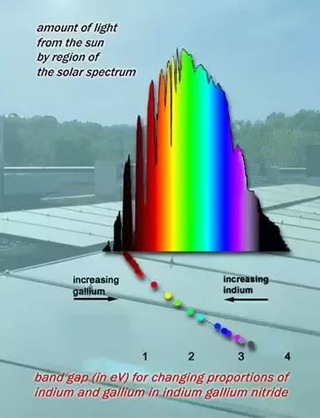

Image from Art Neuendorffer

The Sun may also be approaching sunset when we compete, so testing for yellow and red is preferable just to make sure that the algorithm works in all situations. Testing for green will not be done as it is expected to work if the test is successful for red and yellow.

To perform accurate localization and navigation, our robot must be able to accurately orient itself to any specified degree of rotation. To do this, the team experimented with the navigation class track value by having the robot travel in a 3x3 square a minimum of 3 times without correction. The navigation class takes the track value into consideration when it calculates the amount of motor rotation needed in order to turn to a certain degree. It was noticed that using the measured length between the wheels as the track value creates some large inconsistencies in the angle (15-20 degrees off from the orientation intended). Therefore, by adjusting the track value through trial and error, we were able to determine a track value that results in the EV3 orienting itself to the heading that was specified. (i.e rotate 360 degrees in place, rotate 90 degrees for each corner in square driver etc). The value that produced the most accurate and consistent performance was a track value of 10.08 cm. (Side note: we did not test the accuracy early on in the project due to the fact that we were still developing prototypes. That meant changing designs: different motor placements, different centers of gravity etc. Therefore, we considered it a waste of the budget to test a prototype design for a high degree of accuracy if the design was most likely to be changed. Once we settled on the design, only then did we test for extreme angle accuracy with the track value adjustments). -Tyrone

*Monday, March 20:* A small continuation of the Exact Wheel Radius Test is conducted to approach an even more exact value than the one found by the calculations. A new test report will not be written, as we are changing the value by about a tenth of a millimeter. This can be done because the robot came slightly short to its desired destination in most runs of the Exact Wheel Radius Test (using its new and calculated value). Thus, a small tweak in the value is permissible and prefered.

The track value found yesterday was around 10.08 cm, while through quick testing today, it was around 10.2 cm. Because the value seems to be inconsistent, the Exact Wheelbase Length (Track Value) Test will be conducted to see what we get.

*Wednesday, March 22:* Preliminary testing of the localization code is complete. Some flaws (more or less clearly defined) were found, but it was a good start. It must be noted that the timer used for this test was an external timer, which only started once the robot started to move. In contrast, the timer of the GUI program used to connect to the robot starts its timer once we click “Start”. There is, on average, a 10 second discrepancy between the press of the button on the GUI and the start of the movement of the robot.

*Wednesday, March 22:* Modification of the localization code is continuing to fix any issues found through the preliminary test performed yesterday.

*Thursday, March 23:* Further formal testing will have to be postponed until after the Beta demo (happening tomorrow at 3:40PM). That said, the software team has been continuously testing the robot independently while writing the code, hence there is no absolute need for formal testing at this time.

*Friday, March 24:* During our meeting with our TA, it was brought to our attention that the testing of how far we can go before needing to localize is something that may be needed to be done, since we plan to localize after every couple of tiles passed in order to fix any imperfections in our navigation. Moreover, we realized that the timer of the GUI program is what will be taken into account. In the preliminary localization test, an external timer was used, which would help save us 10 seconds every time. This issue was fixed right away (in the code), thus allowing the robot to start moving once the GUI’s timer starts. Final tests are done before the Beta demo to ensure localization works.

It was also mentioned that the maximum length of a gap between two separate fields would not be big enough to have a pen fit in between. A test should be conducted to test the worst possible scenario, to see whether or not the robot operates properly around these “truncated” lines.

The Beta demo has passed, and it wasn’t a success. After localizing, the robot did not orient itself perfectly. For short distances covered in the R&D phase, such errors in angles were satisfactory. At this stage however, where distances covered are greatly increased, such errors are decisive in whether the ball will go through the hoop or not. More testing was done, and the error in the initial angle (after localizing) was not reduced. The problem is in either the localization or the navigation class (or both). An executive decision was made in favor of modifying the hardware design. The new hardware changes include the addition of a light sensor on both sides of the EV3. This permits the robot to correct the heading of travel by using the grid lines on the platform (see section 10.3 in the Hardware Document).

In addition to the completion of the second (and last) part of the Localization Test, a “mini” (and unofficial) Varying Ambient Light Test was performed. It was done in the small room near the lab (where the Beta demo took place), with the lights off and a bright flashlight pointing at the path of the robot from a close distance (an increase in ambient light levels relative to normal conditions of that room). Although the robot worked normally in these conditions, a more formal test will be performed.

*Monday, March 27:* Determining the landing spot of the ball is important for this project, as there are specifications regarding that provided by the client (the landing site must be within a variable number which is less than or equal to 4 tiles long). The hardware team leader, Tristan, has mentioned that, through his preliminary testing, the ball always lands within the minimum area limits (that of 2x2 tiles). For that reason, testing will only be done by varying the launching distance, while the bounce area will always be minimal. Based on this information, a Ball Launching Consistency Test is written, which is similar to the Lab 5 in the R&D phase and will test mainly the consistency of the launches

The Navigation Test is written next, based on the input of our TA in our last meeting and the recent implementations in software. This test will determine how often localization will be performed in order to ensure continuous correction in the robot’s path. This is crucial, especially since our track value is highly prone to random fluctuations (this phenomenon was also noticed by the rest of the team throughout testing, as results in tests vary from day to day). The test will be performed without the use of correction.

*Wednesday, March 29:* The Navigation and Ongoing Localization Test has been written, and is part of Phase 3 of the testing process, where different software programs are combined and tested together. We’re encountering problems with threads calling motor functions simultaneously which causes the robot to spin out of control at random times. We are currently trying to optimize the software to run with the least amount of threads possible. This test will not include any object avoidance techniques, so it is not a test of the final product.

*Thursday, March 30:* The Varying Ambient Light Test has been performed, and results show that the light sensor works fine without any correcting algorithm. Moreover, troubleshooting/testing of the correction using continuous localization is continuing, as random errors are occurring at seemingly different times. It is suspected that threads are interfering with each other (namely correction and navigation). Also, the Ball Launching Test has been completed.

*Friday, March 31*: Optimized software has been created using the least amount of threads possible. The program works, as our robot is able to successfully localize on the go, navigate and correct the travel direction should any of the turns be off by a few degrees.

A Navigation and Ongoing Localization (X/Y Correction) Test has been developed, in order to work on and optimize the X/Y Correction routine. We have previously found out through the Navigation Test that the actual distance recommended to perform the X/Y correction routine is every 5 tiles. However, for the sake of faster analysis in this test, the X/Y correction will be done after every two tiles.

*Saturday, April 1st*: Completion of the Navigation and Ongoing Localization (X/Y Correction) Test. The robot has gone through a test trial travelling from one corner to the ball dispenser. The robot is able to successfully retrieve the ball. The software team now works on adapting the program so that the robot can receive different information via wifi and act accordingly. Integrating of the obstacle avoidance with our main program is also being done. -Tyrone

*Sunday, April 2nd:* Completion of the Navigation and Obstacle Avoidance Test.

*Tuesday, April 4th:* Completion of the integration testing phase. We should be ready for the competition if all goes well. It must be noted that although the tests in phase 3 took less space to record the results, these were the tests that required the most amount of attention and time.